COURSE CODE: PRAC101 Section: BSIT - 4107
COURSE TITLE: OJT / PRACTICUM 1
TERM: 1st Semester, SY 2025-2026
PROFESSOR: MR. EMERSON GELERA
NAME OF STUDENT: DELA CRUZ, RHUARY D.

OJT NARRATIVE REPORT

- TOPIC: Familiarizing with AI Fundamentals
- SPEAKER: MR. MARC TONIDO
- DURATION: 3:45 PM - 4:45 PM
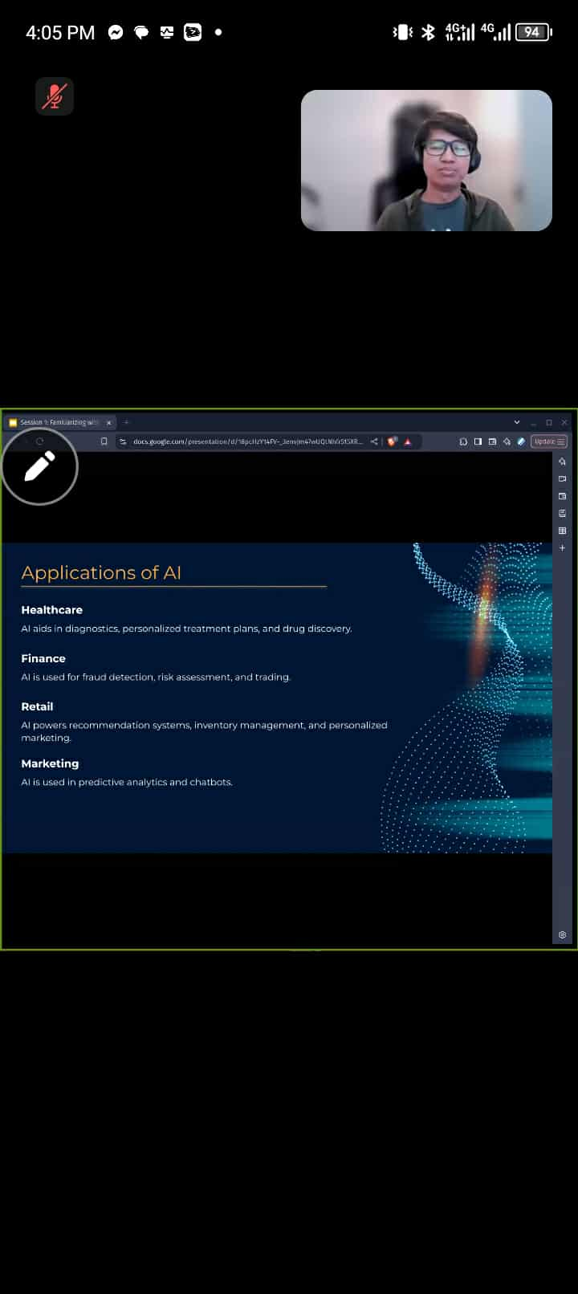
- SCREENSHOT OF DUTY


- REFLECTION
Familiarizing with AI Fundamentals

The first session was about understanding the basics of Artificial Intelligence (AI) and how it affects our daily lives.
We started by learning what AI is. AI means making machines or computers that can think and act like humans. They can understand language, recognize patterns, solve problems, and make decisions. The session also introduced the main parts of AI such as Machine Learning, Deep Learning, Natural Language Processing (NLP), and Computer Vision. These concepts explain how AI can learn from data, process human language, and even recognize images and objects.
We also discussed the different types of AI. Narrow AI is designed for specific tasks, like chatbots. General AI is still only an idea, which would allow machines to do anything a human can do. Superintelligent AI is a future possibility where machines might become smarter than humans.
The session showed how AI is already part of everyday life. In healthcare, AI helps with diagnosis and treatment. In finance, it helps detect fraud and manage risks. In retail and marketing, it powers recommendation systems and chatbots.
We also looked at current trends in AI. These include Generative AI (like GPT-4 and DALL·E), Autonomous Systems (such as self-driving cars and drones), and AI being used to help with environmental sustainability.
Finally, the session discussed the challenges and ethical issues of AI. Some concerns are bias and fairness, privacy and security, job loss due to automation, and lack of transparency in AI decisions. There are also issues about who is responsible when AI makes mistakes, and whether people have given proper consent for their data to be used.
Overall, this session helped us understand the meaning, uses, and challenges of AI. It gave us a clear idea of how AI is shaping the world today and what important questions need to be asked for its future use.

